**Lab7**

Activity 1: Modify the Task 2 – Lab 6, show the contacts in a listview. Name, Phone Number and email along with a sample image on left side of the contact.

MainActivity:

package com.example.contactlist;  
  
import androidx.appcompat.app.AppCompatActivity;  
  
import android.os.Bundle;  
import android.widget.ListView;  
  
import java.util.ArrayList;  
  
public class MainActivity extends AppCompatActivity {  
  
 ArrayList<User> ListofUsers = new ArrayList<User>();  
 @Override  
 protected void onCreate(Bundle savedInstanceState) {  
 super.onCreate(savedInstanceState);  
 setContentView(R.layout.*activity_main*);  
 UserAdapter adapter = new UserAdapter(this, R.layout.*contact_view*, ListofUsers);  
 ListView listView = (ListView) findViewById(R.id.*listView*);  
 listView.setAdapter(adapter);  
  
 User user1 = new User("Safdar", "safdar@gmail.com", "03352284313", 6);  
 adapter.add(user1);  
 User user2 = new User("Nazeer", "nazerahmed@gmail.com", "0335484313", 2);  
 adapter.add(user2);  
 User user3 = new User("Hasibullah", "hasib@gmail.com", "02352284313", 3);  
 adapter.add(user3);  
 User user4 = new User("Arslan Bhutto", "arslan@gmail.com", "03052284313", 4);  
 adapter.add(user4);  
 User user5 = new User("Ghafoor Bhutto", "ghafoor@gmail.com", "003243455546", 5);  
 adapter.add(user5);  
 }  
}

Contact_view.xml

*<?*xml version="1.0" encoding="utf-8"*?>*<androidx.constraintlayout.widget.ConstraintLayout  
 xmlns:android="http://schemas.android.com/apk/res/android"  
 xmlns:app="http://schemas.android.com/apk/res-auto"  
 xmlns:tools="http://schemas.android.com/tools"  
 android:layout_width="match_parent"  
 android:layout_height="match_parent">  
  
 <LinearLayout  
 android:layout_width="match_parent"  
 android:layout_height="100dp"  
 android:orientation="horizontal"  
 tools:layout_editor_absoluteX="0dp"  
 tools:layout_editor_absoluteY="1dp"  
 tools:ignore="MissingConstraints"  
 android:gravity="center_vertical"  
 >  
  
 <ImageView  
 android:id="@+id/profile"  
 android:layout_width="80dp"  
 android:layout_height="80dp"  
 app:srcCompat="@drawable/person"  
 tools:ignore="VectorDrawableCompat" />  
  
 <LinearLayout  
 android:layout_width="match_parent"  
 android:layout_height="100dp"  
 android:layout_marginStart="10dp"  
 android:layout_marginLeft="10dp"  
 android:gravity="center_vertical"  
 android:orientation="vertical"  
 tools:ignore="MissingConstraints"  
 tools:layout_editor_absoluteX="0dp"  
 tools:layout_editor_absoluteY="1dp">  
  
 <TextView  
 android:id="@+id/name"  
 android:layout_width="match_parent"  
 android:layout_height="20dp"  
 android:layout_marginBottom="10dp"  
 android:text="Name" />  
  
 <TextView  
 android:id="@+id/email"  
 android:layout_width="match_parent"  
 android:layout_height="20dp"  
 android:layout_marginBottom="10dp"  
 android:text="Email" />  
  
 <TextView  
 android:id="@+id/number"  
 android:layout_width="match_parent"  
 android:layout_height="20dp"  
 android:text="Number" />  
 </LinearLayout>  
  
 </LinearLayout>  
</androidx.constraintlayout.widget.ConstraintLayout>

User.java

package com.example.contactlist;  
  
import java.util.Enumeration;  
  
public class User {  
  
 int imageId;  
 public String name, email, number;  
  
 public User(String name, String email, String number, int imageId) {  
 this.name = name;  
 this.email = email;  
 this.number = number;  
 this.imageId = imageId;  
 }  
  
 public String getName() {  
 return name;  
 }  
  
 public String getNumber(){  
 return number;  
 }  
  
 public String getEmail() {  
 return email;  
 }  
  
 public int getImageId() {  
 return imageId;  
 }  
  
}

UserAdapter

package com.example.contactlist;  
  
import android.content.Context;  
import android.view.ContextThemeWrapper;  
import android.view.LayoutInflater;  
import android.view.View;  
import android.view.ViewGroup;  
import android.widget.ArrayAdapter;  
import android.widget.ImageView;  
import android.widget.TextView;  
  
import androidx.annotation.NonNull;  
import androidx.annotation.Nullable;  
  
import java.util.ArrayList;  
  
public class UserAdapter extends ArrayAdapter<User> {  
  
 Context context;  
 int resource;  
 ArrayList<User> users;  
  
 public UserAdapter(Context context, int resource, ArrayList<User> users){  
 super(context, resource, users);  
 this.context = context;  
 this.resource = resource;  
 this.users = users;  
  
 }  
  
  
  
 @NonNull  
 @Override  
 public View getView(int position, @Nullable View convertView, @NonNull ViewGroup parent) {  
 convertView = LayoutInflater.*from*(getContext()).inflate(resource, parent, false);  
 User user = this.users.get(position);  
  
 TextView name = convertView.findViewById(R.id.*name*);  
 TextView email = convertView.findViewById(R.id.*email*);  
 TextView number = convertView.findViewById(R.id.*number*);  
 ImageView image = convertView.findViewById(R.id.*profile*);  
  
 name.setText(user.name);  
 email.setText(user.email);  
 number.setText(user.number);  
 image.setImageResource(R.drawable.*person*+user.imageId);  
  
 return convertView;  
 }  
}

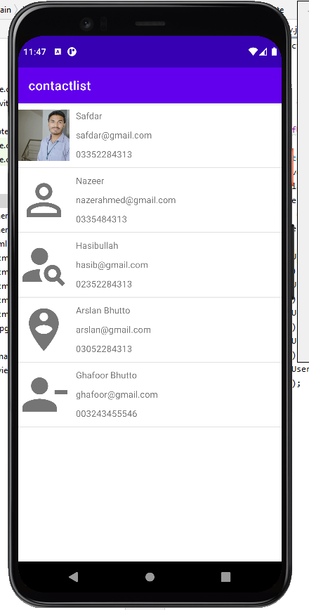

**Activity 2:** Create a “Presidential Election Candidates” App, which will list all the candidates being

available for election, clicking on its image will load the detail of the candidate in another fragment.

MainActivity.java

import androidx.appcompat.app.AppCompatActivity;  
  
import android.os.Bundle;  
  
public class MainActivity extends AppCompatActivity {  
  
 @Override  
 protected void onCreate(Bundle savedInstanceState) {  
 super.onCreate(savedInstanceState);  
 setContentView(R.layout.*activity_main*);  
 }  
}

listFragment.java  
  
import android.os.Bundle;  
  
import androidx.fragment.app.Fragment;  
import androidx.fragment.app.FragmentManager;  
  
import android.view.LayoutInflater;  
import android.view.View;  
import android.view.ViewGroup;  
import android.widget.AdapterView;  
import android.widget.ListView;  
  
public class listFragment extends Fragment {  
  
 *// TODO: Rename parameter arguments, choose names that match  
 // the fragment initialization parameters, e.g. ARG_ITEM_NUMBER* private static final String *ARG_PARAM1* = "param1";  
 private static final String *ARG_PARAM2* = "param2";  
  
 *// TODO: Rename and change types of parameters* private String mParam1;  
 private String mParam2;  
  
 public listFragment() {  
 *// Required empty public constructor* }  
  
 @Override  
 public void onCreate(Bundle savedInstanceState) {  
 super.onCreate(savedInstanceState);  
 if (getArguments() != null) {  
 mParam1 = getArguments().getString(*ARG_PARAM1*);  
 mParam2 = getArguments().getString(*ARG_PARAM2*);  
 }  
 }  
  
 ListView list;  
 @Override  
 public View onCreateView(LayoutInflater inflater, ViewGroup container,  
 Bundle savedInstanceState) {  
 *// Inflate the layout for this fragment* View view = inflater.inflate(R.layout.*fragment_list*, container, false);  
  
 list = view.findViewById(R.id.*listview*);  
 list.setOnItemClickListener(new AdapterView.OnItemClickListener() {  
 @Override  
 public void onItemClick(AdapterView<?> parent, View view, int position, long id) {  
 detailsFragment fragment = new detailsFragment(position);  
 FragmentManager manager = getActivity().getSupportFragmentManager();  
 manager.beginTransaction().replace(R.id.*details*,fragment).commit();  
  
 }  
 });  
 return view;  
 }  
}

detailsFragments.java

import android.os.Bundle;  
  
import androidx.fragment.app.Fragment;  
  
import android.view.LayoutInflater;  
import android.view.View;  
import android.view.ViewGroup;  
import android.widget.ImageView;  
import android.widget.TextView;  
  
public class detailsFragment extends Fragment {  
  
 *// TODO: Rename parameter arguments, choose names that match  
 // the fragment initialization parameters, e.g. ARG_ITEM_NUMBER* private static final String *ARG_PARAM1* = "param1";  
 private static final String *ARG_PARAM2* = "param2";  
  
 *// TODO: Rename and change types of parameters* private String mParam1;  
 private String mParam2;  
  
 int position;  
 int[] imagesArray;  
 String[] description;  
 public detailsFragment(int position) {  
 *// Required empty public constructor* this.position = position;  
 }  
  
  
 @Override  
 public void onCreate(Bundle savedInstanceState) {  
 super.onCreate(savedInstanceState);  
 if (getArguments() != null) {  
 mParam1 = getArguments().getString(*ARG_PARAM1*);  
 mParam2 = getArguments().getString(*ARG_PARAM2*);  
 }  
 imagesArray = new int[]{R.drawable.*clinton*,R.drawable.*sanders*,R.drawable.*omalley*,R.drawable.*chafee*,R.drawable.*trump*,R.drawable.*carson*,R.drawable.*rubio*,R.drawable.*bush*};  
 description = new String[]{"Former United States Secretary of State","Member of the United States Senate","Former Governor of Maryland","Former Governor of Rhode Island","45th U.S. President",  
 "Former United States Secretary of Housing and Urban Development","Member of the United States Senate","Former Governor of Florida"};  
 }  
  
 @Override  
 public View onCreateView(LayoutInflater inflater, ViewGroup container,  
 Bundle savedInstanceState) {  
 *// Inflate the layout for this fragment* View view = inflater.inflate(R.layout.*fragment_details*, container, false);  
 ImageView img = view.findViewById(R.id.*imageView*);  
 TextView txt = view.findViewById(R.id.*detail*);  
 img.setImageResource(imagesArray[position]);  
 txt.setText(description[position]);  
 return view;  
 }  
}

activity_main.xml

*<?*xml version="1.0" encoding="utf-8"*?>*<LinearLayout xmlns:android="http://schemas.android.com/apk/res/android"  
 xmlns:tools="http://schemas.android.com/tools"  
 android:layout_width="match_parent"  
 android:layout_height="match_parent"  
 android:orientation="horizontal"  
 android:weightSum="1"  
 tools:context=".MainActivity">  
  
 <fragment  
 android:id="@+id/list"  
 android:name="com.example.electionlab7_2.listFragment"  
 android:layout_width="0dp"  
 android:layout_weight="0.3"  
 tools:layout="@layout/fragment_list"  
 android:layout_height="match_parent">  
 </fragment>  
 <FrameLayout  
 android:id="@+id/details"  
 android:layout_width="0dp"  
 android:layout_weight="0.7"  
 tools:layout="@layout/fragment_details"  
 android:layout_height="match_parent">  
 </FrameLayout>  
</LinearLayout>

Fragment_details.xml

*<?*xml version="1.0" encoding="utf-8"*?>*<LinearLayout xmlns:android="http://schemas.android.com/apk/res/android"  
 xmlns:app="http://schemas.android.com/apk/res-auto"  
 xmlns:tools="http://schemas.android.com/tools"  
 android:layout_width="match_parent"  
 android:layout_height="match_parent"  
 android:orientation="vertical"  
 tools:context=".detailsFragment">  
  
 <ImageView  
 android:id="@+id/imageView"  
 android:layout_width="match_parent"  
 android:layout_height="200dp"  
 android:layout_marginTop="60dp"  
 tools:src="@tools:sample/avatars" />  
  
 <TextView  
 android:id="@+id/detail"  
 android:layout_width="match_parent"  
 android:layout_height="wrap_content"  
 android:gravity="center"  
 android:text="TextView"  
 android:textSize="20dp" />  
</LinearLayout>

Fragment_list.xml

*<?*xml version="1.0" encoding="utf-8"*?>*<FrameLayout xmlns:android="http://schemas.android.com/apk/res/android"  
 xmlns:tools="http://schemas.android.com/tools"  
 android:layout_width="match_parent"  
 android:layout_height="match_parent"  
 tools:context=".listFragment">  
  
 *<!-- TODO: Update blank fragment layout -->* <ListView  
 android:id="@+id/listview"  
 android:layout_width="match_parent"  
 android:layout_height="match_parent"  
 android:entries="@array/candidates" />  
  
</FrameLayout>

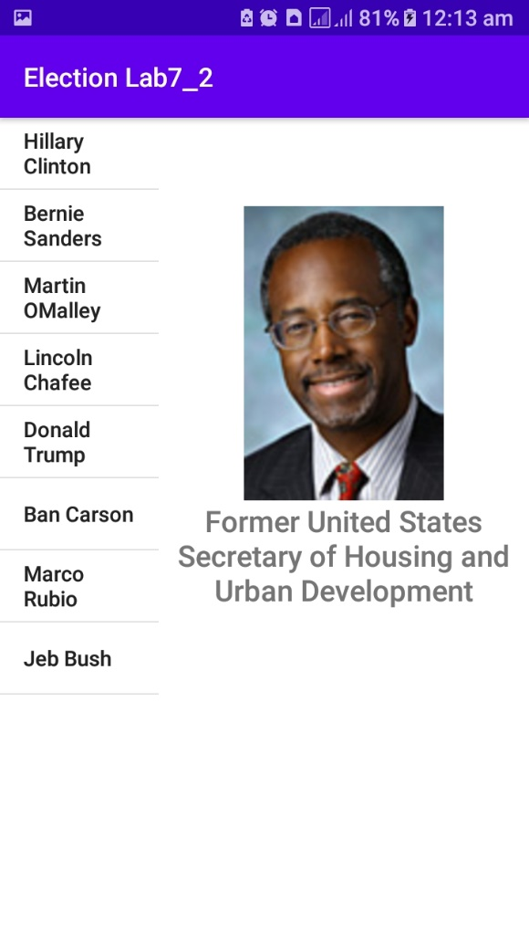

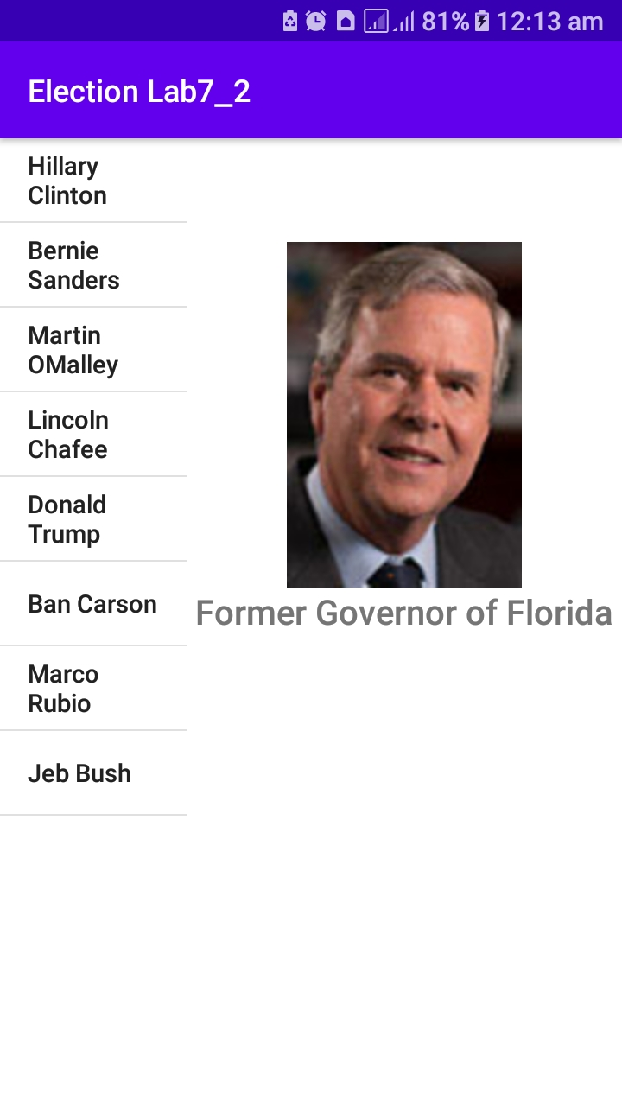

**Activity 3:** The Moquelumnan languages are a group of endangered languages spoken in Central California in the Sierra Nevada. In this exercise, you will build an app to help Moquelumnan language students practice their number skills. The screen, as shown below, will provide a list of number of items from 1 to 10. For each number provide an image, the written English name, the numeric value, and an audio sound that will play when the user taps directly on the list item. Use a ListView powered by a custom ArrayAdapter

MainActivity.java  
  
import androidx.appcompat.app.AppCompatActivity;  
  
import android.media.MediaPlayer;  
import android.net.Uri;  
import android.os.Bundle;  
import android.view.View;  
import android.widget.AdapterView;  
import android.widget.ListView;  
  
import java.util.ArrayList;  
  
public class MainActivity extends AppCompatActivity {  
  
 int[] sounds;  
 MediaPlayer md;  
 @Override  
 protected void onCreate(Bundle savedInstanceState) {  
 super.onCreate(savedInstanceState);  
 setContentView(R.layout.*activity_main*);  
  
 sounds = new int[]{R.raw.*number_one*,R.raw.*number_two*,R.raw.*number_three*,R.raw.*number_four*,R.raw.*number_five*,  
 R.raw.*number_six*,R.raw.*number_seven*,R.raw.*number_eight*,R.raw.*number_nine*,R.raw.*number_ten*};  
  
  
 ArrayList<Numbers> list = new ArrayList<>();  
 list.add(new Numbers("1","One",R.drawable.*number_one*));  
 list.add(new Numbers("2","Two",R.drawable.*number_two*));  
 list.add(new Numbers("3","Three",R.drawable.*number_three*));  
 list.add(new Numbers("4","Four",R.drawable.*number_four*));  
 list.add(new Numbers("5","Five",R.drawable.*number_five*));  
 list.add(new Numbers("6","Six",R.drawable.*number_six*));  
 list.add(new Numbers("7","Seven",R.drawable.*number_seven*));  
 list.add(new Numbers("8","Eight",R.drawable.*number_eight*));  
 list.add(new Numbers("9","Nine",R.drawable.*number_nine*));  
 list.add(new Numbers("10","Ten",R.drawable.*number_ten*));  
  
 MyAdapter adapter = new MyAdapter(this,R.layout.*custom_list_layout*,list);  
 ListView listView = findViewById(R.id.*listview*);  
 listView.setAdapter(adapter);  
  
 listView.setOnItemClickListener(new AdapterView.OnItemClickListener() {  
 @Override  
 public void onItemClick(AdapterView<?> parent, View view, int position, long id) {  
 md = MediaPlayer.*create*(getApplicationContext(),sounds[position]);  
 md.start();  
 }  
 });  
 }  
  
}

myAdapter.java  
  
import android.content.Context;  
import android.view.LayoutInflater;  
import android.view.View;  
import android.view.ViewGroup;  
import android.widget.ArrayAdapter;  
import android.widget.ImageView;  
import android.widget.TextView;  
  
import androidx.annotation.NonNull;  
import androidx.annotation.Nullable;  
  
import java.util.List;  
  
public class MyAdapter extends ArrayAdapter {  
  
 Context context;  
 int resource;  
 List<Numbers> list;  
 public MyAdapter(@NonNull Context context, int resource, @NonNull List<Numbers> objects) {  
 super(context, resource, objects);  
 this.context = context;  
 this.resource = resource;  
 this.list = objects;  
 }  
  
 @NonNull  
 @Override  
 public View getView(int position, @Nullable View convertView, @NonNull ViewGroup parent) {  
 convertView = LayoutInflater.*from*(getContext()).inflate(R.layout.*custom_list_layout*, parent, false);  
 TextView eng_number = convertView.findViewById(R.id.*textView*);  
 TextView int_number = convertView.findViewById(R.id.*textView2*);  
 ImageView img = convertView.findViewById(R.id.*imageView*);  
 Numbers numbers = list.get(position);  
 eng_number.setText(numbers.numbering);  
 int_number.setText(numbers.counting);  
 img.setImageResource(numbers.img);  
 return convertView;  
 }  
}

Numbers.java  
  
public class Numbers {  
 String counting;  
 String numbering;  
 int img;  
  
 public Numbers(String counting, String numbering, int img) {  
 this.counting = counting;  
 this.numbering = numbering;  
 this.img = img;  
 }  
 public int getImg() {  
 return img;  
 }  
  
 public void setImg(int img) {  
 this.img = img;  
 }  
 public String getCounting() {  
 return counting;  
 }  
  
 public void setCounting(String counting) {  
 this.counting = counting;  
 }  
  
 public String getNumbering() {  
 return numbering;  
 }  
  
 public void setNumbering(String numbering) {  
 this.numbering = numbering;  
 }  
}

activity_main.xml

*<?*xml version="1.0" encoding="utf-8"*?>*<androidx.constraintlayout.widget.ConstraintLayout xmlns:android="http://schemas.android.com/apk/res/android"  
 xmlns:app="http://schemas.android.com/apk/res-auto"  
 xmlns:tools="http://schemas.android.com/tools"  
 android:layout_width="match_parent"  
 android:layout_height="match_parent"  
 tools:context=".MainActivity">  
  
 <ListView  
 android:id="@+id/listview"  
 android:layout_width="match_parent"  
 android:layout_height="match_parent" />  
</androidx.constraintlayout.widget.ConstraintLayout>

Custom_list.xml

*<?*xml version="1.0" encoding="utf-8"*?>*<LinearLayout xmlns:android="http://schemas.android.com/apk/res/android"  
 xmlns:app="http://schemas.android.com/apk/res-auto"  
 xmlns:tools="http://schemas.android.com/tools"  
 android:layout_width="match_parent"  
 android:layout_height="100dp"  
 android:layout_margin="10dp"  
 android:background="#B4ECE5"  
 android:orientation="horizontal"  
 android:weightSum="1">  
  
 <ImageView  
 android:id="@+id/imageView"  
 android:layout_width="0dp"  
 android:layout_height="wrap_content"  
 android:layout_weight="0.3"  
 tools:srcCompat="@tools:sample/avatars" />  
  
 <LinearLayout  
 android:layout_width="0dp"  
 android:layout_height="match_parent"  
 android:layout_weight="0.7"  
 android:orientation="vertical">  
  
 <TextView  
 android:id="@+id/textView"  
 android:layout_width="match_parent"  
 android:layout_height="wrap_content"  
 android:text="TextView"  
 android:textSize="20dp" />  
  
 <TextView  
 android:id="@+id/textView2"  
 android:layout_width="match_parent"  
 android:layout_height="wrap_content"  
 android:text="TextView"  
 android:textSize="16dp" />  
 </LinearLayout>  
</LinearLayout>

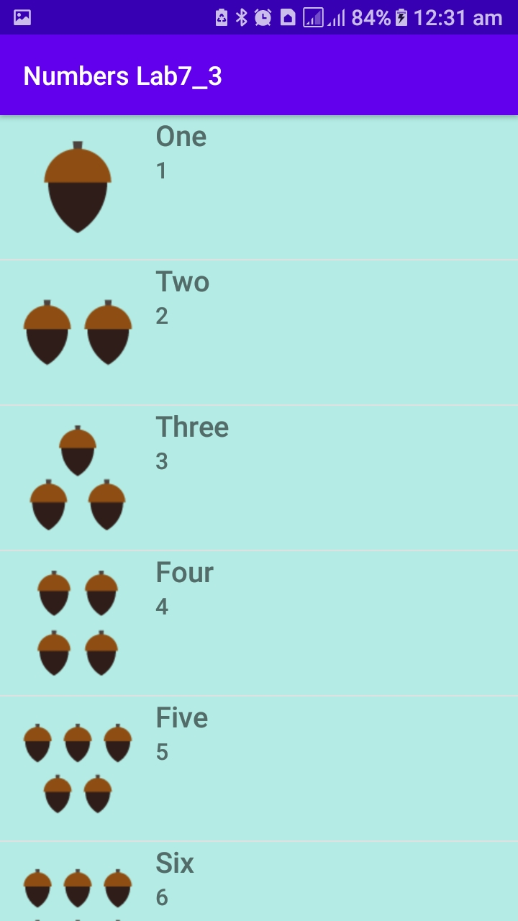

**Activity 4:** Modify Activity 1 – Lab 6, let the user able to cycle through the stories loaded in a list from

database. And able to read any story when user clicks on it.

MainActivity.java

ublic class MainActivity extends AppCompatActivity {  
  
 @Override  
 protected void onCreate(Bundle savedInstanceState) {  
 super.onCreate(savedInstanceState);  
 setContentView(R.layout.*activity_main*);  
 }  
 public void gotoWords(View view)  
 {  
 Intent intent = new Intent(this,FillWords.class);  
 startActivity(intent);  
  
 }  
}

Story.java  
  
import androidx.appcompat.app.AppCompatActivity;  
  
import android.content.Intent;  
import android.os.Bundle;  
import android.view.View;  
import android.widget.TextView;  
  
import java.io.BufferedReader;  
import java.io.IOException;  
import java.io.InputStream;  
import java.io.InputStreamReader;  
import java.nio.file.Files;  
import java.nio.file.Path;  
import java.nio.file.Paths;  
import java.util.ArrayList;  
import java.util.List;  
  
public class Story extends AppCompatActivity {  
  
 TextView txt;  
 Intent intent;  
 @Override  
 protected void onCreate(Bundle savedInstanceState) {  
 super.onCreate(savedInstanceState);  
 setContentView(R.layout.*activity_story*);  
 txt = findViewById(R.id.*story*);  
 int count = 0;  
 String textAll="";  
 String replace="";  
 intent = getIntent();  
 int file = intent.getIntExtra("index",0);  
 ArrayList blanks = (ArrayList) intent.getSerializableExtra("list");  
 System.*out*.println(blanks.get(0).toString());  
 InputStream inputStream = getResources().openRawResource(file);  
 BufferedReader bufferedReader= new BufferedReader(new InputStreamReader(inputStream));  
 String eachline = null;  
 try {  
 eachline = bufferedReader.readLine();  
 System.*out*.println(eachline+" hello ");  
 } catch (IOException e) {  
 e.printStackTrace();  
 }  
 while (eachline != null) {  
 *// `the words in the file are separated by space`, so to get each words* String[] words = eachline.split(" ");  
 for (String word:words  
 ) {  
 if(word.contains("<"))  
 {  
 word = word.replaceAll(word,blanks.get(count).toString());  
 count++;  
 }  
 textAll+=word+" ";  
 System.*out*.println(textAll);  
 }  
 try {  
 eachline = bufferedReader.readLine();  
 } catch (IOException e) {  
 e.printStackTrace();  
 }  
 }  
 txt.setText(textAll);  
 }  
 public void MakeOtherStory(View view)  
 {  
 Intent i = new Intent(this,FillWords.class);  
 startActivity(i);  
 finish();  
 }  
}

FillWords.java  
  
import android.content.Intent;  
import android.os.Bundle;  
import android.view.View;  
import android.widget.EditText;  
import android.widget.TextView;  
import android.widget.Toast;  
  
import java.io.BufferedReader;  
import java.io.FileReader;  
import java.io.IOException;  
import java.io.InputStream;  
import java.io.InputStreamReader;  
import java.util.ArrayList;  
import java.util.Collection;  
import java.util.Iterator;  
import java.util.List;  
import java.util.ListIterator;  
import java.util.Random;  
  
public class FillWords extends AppCompatActivity {  
  
 int[] files;  
 int index = 0;  
 ArrayList blanks;  
 EditText txt;  
 int count = 1;  
 TextView summary;  
 TextView fill;  
 ArrayList listofWords;  
 @Override  
 protected void onCreate(Bundle savedInstanceState) {  
 super.onCreate(savedInstanceState);  
 setContentView(R.layout.*activity_fill_words*);  
 files = new int[]{R.raw.*madlib0*,R.raw.*madlib1*,R.raw.*madlib2*,R.raw.*madlib3*,R.raw.*madlib4*};  
 txt = findViewById(R.id.*editTextTextPersonName*);  
 summary =findViewById(R.id.*summary*);  
 fill = findViewById(R.id.*fill*);  
  
 Random rand = new Random();  
 index = rand.nextInt(4);  
 blanks = new ArrayList();  
 listofWords = new ArrayList();  
  
 InputStream inputStream = getResources().openRawResource(files[index]);  
 BufferedReader bufferedReader= new BufferedReader(new InputStreamReader(inputStream));  
 String eachline = null;  
 try {  
 eachline = bufferedReader.readLine();  
  
 } catch (IOException e) {  
 e.printStackTrace();  
 }  
 while (eachline != null) {  
 *// `the words in the file are separated by space`, so to get each words* String[] words = eachline.split(" ");  
 System.*out*.println(words + " hello");  
 if(eachline.contains("<"))  
 {  
 for (String word:words  
 ) {  
 if(word.contains("<"))  
 {  
 String text = word.substring(word.indexOf("<")+1,word.indexOf(">"));  
 System.*out*.println(text);  
 blanks.add(text);  
 }  
  
 }  
  
 }  
 try {  
 eachline = bufferedReader.readLine();  
  
 } catch (IOException e) {  
 e.printStackTrace();  
 }  
 }  
 txt.setHint(blanks.get(0).toString());  
 summary.setText((blanks.size())+" word(s) left");  
 fill.setText("please type a/an "+blanks.get(0));  
 }  
 public void newWord(View view)  
 {  
 if(!txt.getText().toString().equals("")) {  
 listofWords.add(txt.getText().toString());  
 if (count < blanks.size()) {  
 txt.setText("");  
 txt.setHint(blanks.get(count).toString());  
 summary.setText((blanks.size() - count) + " word(s) left");  
 fill.setText("please type a/an " + blanks.get(count));  
 count++;  
 } else {  
 Intent intent = new Intent(this, Story.class);  
 intent.putExtra("index", files[index]);  
 intent.putExtra("list", listofWords);  
 startActivity(intent);  
 finish();  
 }  
 }  
 else  
 {  
 Toast.*makeText*(this, "please enter text", Toast.*LENGTH_SHORT*).show();  
 }  
 }  
}

